

My Target: ____ / 43 or ______ % Complete on the day of the test

🖒 🖓 (Circle when your assignment is handed back)

|  |  |  |
| --- | --- | --- |
| Total marks **43** | **%** | **Weight**  **7.5 %** |
|  |  |  |
| Validation 18 | **%** | **Weight**  **4 %** |
|  |  |  |

**Name: ________________________________**

**Teacher: _________________________________**

Year 9 Humanities & Social Sciences: *Civics & Citizenship*

***Assessment 8 –* In-Class Multiple Choice, Short Answer Responses and Validation**

**Instructions: Complete all questions. Working time 55 minutes; 5 minutes reading time.**

**Section One – Multiple Choice**

1. What does the term “criminal law” refer to?
2. Laws relating to private relations between members of a community.
3. Laws relating to behaviour that is prohibited by the government.
4. Laws relating to relationships between countries or states.
5. Laws relating to relationships between the government and its citizens.
6. In Western Australia, if you are under 18 and accused of a crime you will have to attend:
7. The Children’s Court.
8. The Supreme Court of Western Australia.
9. The District Court of Western Australia.
10. The Magistrates Court of Western Australia.
11. Which Western Australian court can hear criminal cases for which the maximum penalty is life imprisonment?
12. Magistrates Court of Western Australia.
13. Coroners Court.
14. Supreme Court of Western Australia.
15. District Court of Western Australia.
16. Which of the following is **NOT** a feature of the Australian legal system?
17. All persons are considered innocent until proven guilty.
18. The power of the government is divided between the judiciary, executive and legislature.
19. All persons are equal before the law.
20. The decisions of all the courts are final and cannot be challenged.
21. In a criminal case the right to a fair trial, means that the trial must be fair to who?
22. The defendant
23. The victim
24. Witnesses
25. All of the above.
26. How many people serve on a jury?
27. 21
28. 12
29. 10
30. 13
31. Laws are made:
32. To protect the society
33. To protect individuals
34. Both (a) and (b)
35. To protect the government
36. The last step in making a law in Parliament is:

a. When the bill is presented to Parliament

b. When it passes its third reading

c. When it is published in the Government Gazette

d. When the Governor or Governor General signs it

1. A person who continually has noisy parties can be sued by one of their neighbours under the section in the law of Torts known as:
2. Negligence
3. Defamation
4. Nuisance
5. Public Order
6. A jury’s job is to:
7. Judge guilt or innocence only
8. Judge guilt or innocence and set the punishment
9. Ask questions of the witnesses
10. All of the above
11. The best term to describe the present political system in Australia is:

a. Constitutional Monarchy

b. Dictatorship

c. Democratic Republic

d. Direct Democracy

**12**. A government minister’s area of responsibility is called their:

a. Cabinet

b. Department

c. Session

d. Portfolio

**13.** The name given to the leader of the majority party in the Lower House of the Federal Parliament is the:

a. Speaker

b. Premier

c. Prime Minister

d. Leader of the Opposition

**14.** The Australian Constitution can only be changed by:

a. Election

b. Law

c. Referendum

d. Amendment

**15.** A book which contains all the names of those people who are able to vote in an election is called a/ an:

a. Electoral roll

1. Membership record
2. Gazette
3. Ballot paper

**16.** A person who stands for parliament but does not belong to any particular   
party is a/an:

* 1. Member
  2. Independent
  3. Non-partisan
  4. Elector

**17.** A law is a rule made by the government or courts which:

a. Applies to all people in the world

b. Applies to all people in the society

c. Applies to all people except the government

d. All the above

**18.** . Nowadays, laws in Australia are made by:

a. State and Federal Courts

b. State and federal Parliament

c. Local councils

d. All of the above

**19.** Which of the following is not a function of government?

a. Legislative

b. Judicial

c. Consultative

d. Executive

**20.** A combination of two or more parties to form an executive or government is:

a. Joint – exercise

b. Coalition

c. Combination

d. Distribution

**Section Two: Short Answer**

**1**.Select 2 Principle of Justice and explain how this principle works

Principle of Justice ________________ (3 Marks)

________________________________________________________________________________________________________________________________________________________________________________________________________________________________________________________________________________________________________________________

______________________________________________________________________________

Principle of Justice _________________ (3 Marks)

______________________________________________________________________________________________________________________________________________________________________________________________________________________________________________________________________________________________________________________________________________________________________________________________________

**2**. Select 2 Challenges to justice and explain how these challenges occur

Challenge to justice _________________________________________ (3 marks)

________________________________________________________________________________________________________________________________________________________________________________________________________________________________________________________________________________________________________________________

______________________________________________________________________________

Challenge to justice _________________________________________ (3 marks)

________________________________________________________________________________________________________________________________________________________________________________________________________________________________________________________________________________________________________________________

______________________________________________________________________________

**3.** Using the source as a guide explain the preferential voting system is used in Australian elections. [A good answer will refer clearly to the source] (4 Marks)

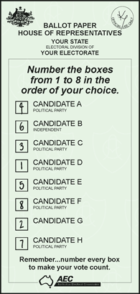

_____________________________________________________

_____________________________________________________

_____________________________________________________

______________________________________________________

_____________________________________________________

_____________________________________________________

_____________________________________________________

_____________________________________________________

_____________________________________________________

__________________________________________________________________________ __________________________________________________________________________ __________________________________________________________________________

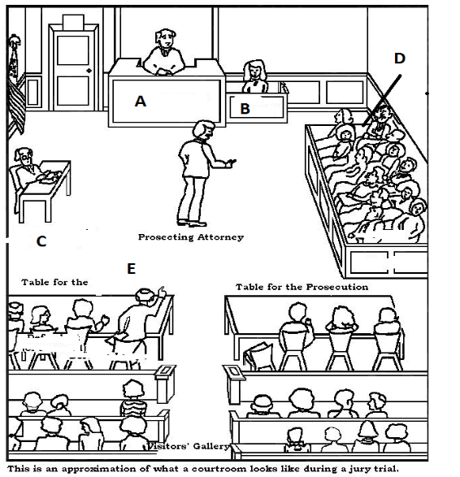

**4. a)** Refer to the source to complete the question below.

Identify the people in the court A to D **(4 marks)**

**A______________________________**

**B______________________________**

**C______________________________**

**D______________________________**

**b)** Select one from Q4a and explain their role in

court. **(3 marks)**

_____________________________________________________________________________

_____________________________________________________________________________

_____________________________________________________________________________

_____________________________________________________________________________

_____________________________________________________________________________

_____________________________________________________________________________

_____________________________________________________________________________

**Validation Section**

1. **Identify** the following *Australian Court System* categories by completing the words. (4 marks)
2. The M____________________________ Court
3. The H____________________________ Court
4. The S____________________________ Court
5. The D___________________________ Court
6. **State** the name of the court in which the following are likely to be heard. (6 marks)

|  |  |
| --- | --- |
| **Case** | **Court** |
| 1. A murder trial |  |
| 1. An appeal from the Western Australian Supreme Court |  |
| 1. A minor traffic offence |  |
| 1. A custody case involving children after divorce |  |
| 1. A civil dispute involving business partners involving $100 million |  |
| 1. A case dealing with an aspect of the Australian Constitution |  |

1. **Explain** the difference between a Criminal and Civil Case. Provide examples to support your explanation. (4 Marks)

________________________________________________________________________________________________________________________________________________________________________________________________________________________________________________________________________________________________________________________

________________________________________________________________________________________________________________________________________________________________________________________________________________________________________________________________________________________________________________________

____________________________________________________________________________________________________________________________________________________________

____________________________________________________________________________________________________________________________________________________________

____________________________________________________________________________________________________________________________________________________________

1. **Explain** the role of the High Court in the Australia. (4 marks)

______________________________________________________________________________________________________________________________________________________________________________________________________________________________________________________________________________________________________________________________________________________________________________________________________________________________________________________________________________________________________________________________________________________________________________________________________________________________________________________________________________________________________________________________________________________________________________________________________________________________________________________________________________________________________________________________________________________________________________________________________________________________________________________________________________________________________________________________________________________________________________________________________________________________________________________________________________________________________________________________________________________________________________